Project Design Phase-II
Solution Requirements (Functional & Non-functional)

Date | 07/03/26
Team ID | SWTID-2026-5992
Project Name | Product Inventory Management System
Maximum Marks | 4 Marks

Functional Requirements:

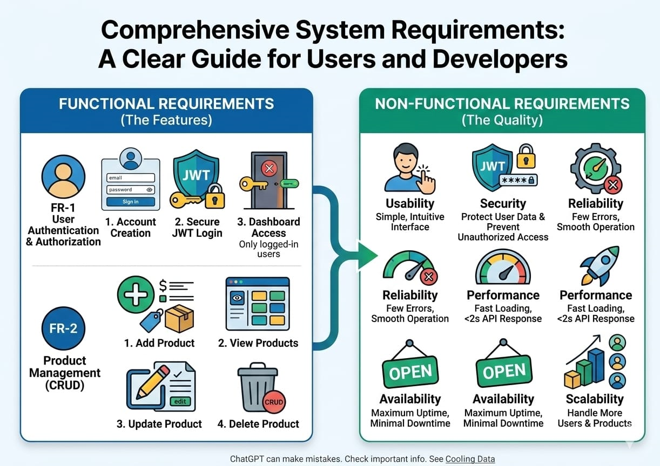

Solution Requirements (Functional & Non-Functional)

A Product Inventory Management System is developed to manage and monitor products, stock levels, suppliers, and sales efficiently. The functional requirements of the system include user authentication to ensure secure access for authorized users such as administrators, managers, and staff. The system allows users to add, update, delete, and view product information including product name, category, price, and quantity. It also tracks inventory levels in real time and automatically updates stock whenever products are sold or restocked. The system provides low-stock alerts to help prevent product shortages. Additionally, it supports supplier management by storing supplier details and enables purchase and sales management to record transactions. The system also offers search options and generates reports such as inventory and sales reports for better decision-making.
The non-functional requirements focus on the quality and performance of the system. The system should be secure, reliable, and user-friendly, ensuring that users can easily operate it. It should provide fast response times and support multiple users simultaneously. Data should be protected through encryption and regular backups to prevent loss. The system should also be scalable, maintainable, and compatible with different devices and modern web browsers to ensure smooth and efficient operation.

